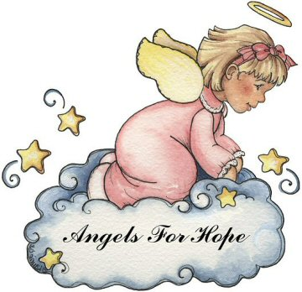

A Few Facts

- Angels for Hope became a nonprofit 501 (c) (3) organization on December 29th 2005.

- Over 180,000 Angels have been mailed to those in need of hope. Along with 75,000 Butterflies and over 7,500 smiley faces.

- Angel volunteers are located in 49 states and 4 countries.
- 100th Birthday Butterfly Club
  - Anyone hitting the milestone of 100 qualifies
- Fallen Soldier Program
  - We are trying to reach the families of every fallen soldier.

- We donate to projects such as Ronald McDonald Houses, Hospices, Relay for Life etc.

WWW.ANGELSFORHOPE.ORG
Media Contact:
Tony Gabner
717-838-4235
tony@angelsforhope.org
History of Angels for Hope

In December of 2002 the original owner of “Angels for Hope” stepped down.

At that time, Kelly Smith assumed the duties of running the group of 15 members, but due to health problems took on a partner, Cindy Gabner, in January, 2003. Due to those health reasons, Kelly had to step down. Angels for Hope became incorporated in April of 2005.

Our Mission Statement

Our mission is to help people send a message of hope and caring by providing them a symbol and the means to deliver it. By offering our crocheted angels, butterflies, and smiley faces free of charge, anyone can touch the life of those in need of hope.

President ….. Cindy Gabner
Secretary …. Tony Gabner
Director … Mary Ehret Holler
Director … Diane Dunkle

To date we have grown to over 600 Angels from all over the world.

